**EXPNO9: CREATE A SNAPHOT**

**AIM:** Create a Snapshot of a VM and Test it by loading the Previous Version/Cloned VM using virtual box.

**Material:**

● VM Workstation software.

● Configurations.

**Procedure:**

**Step 1:**

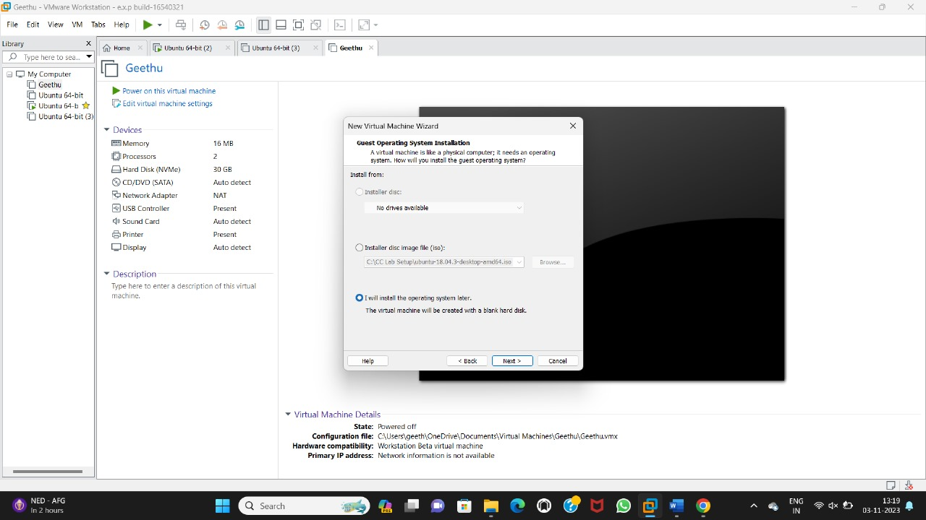

**Step 2:**

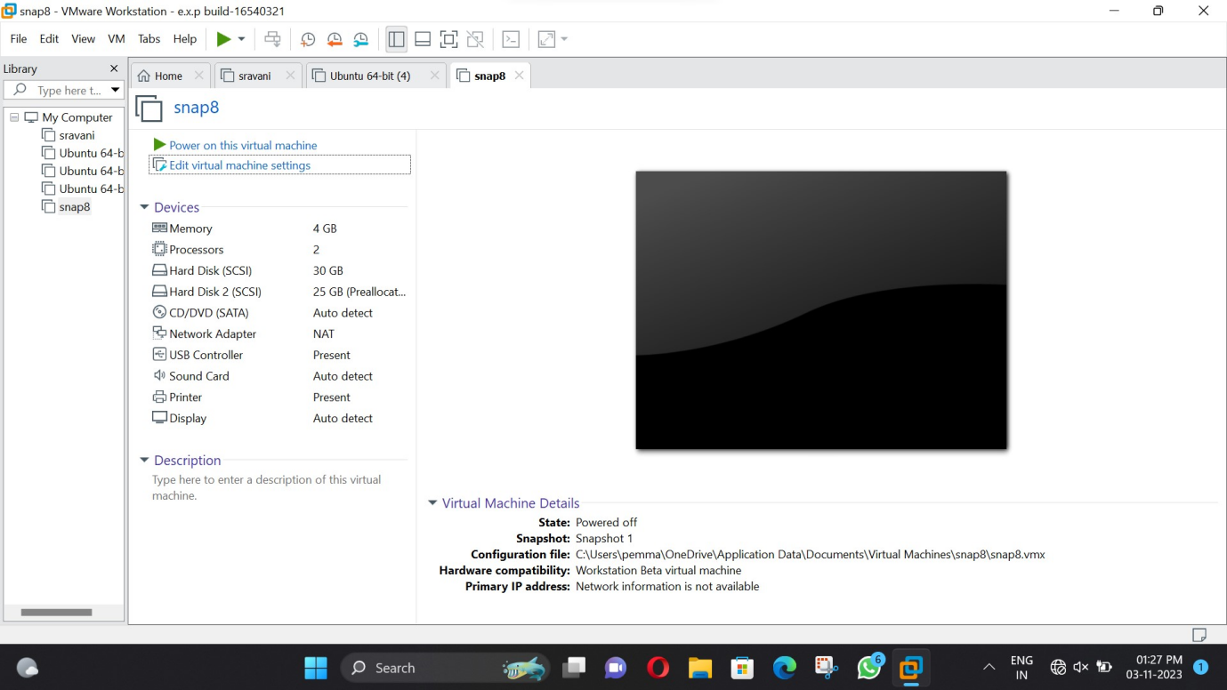

**Step 3:**

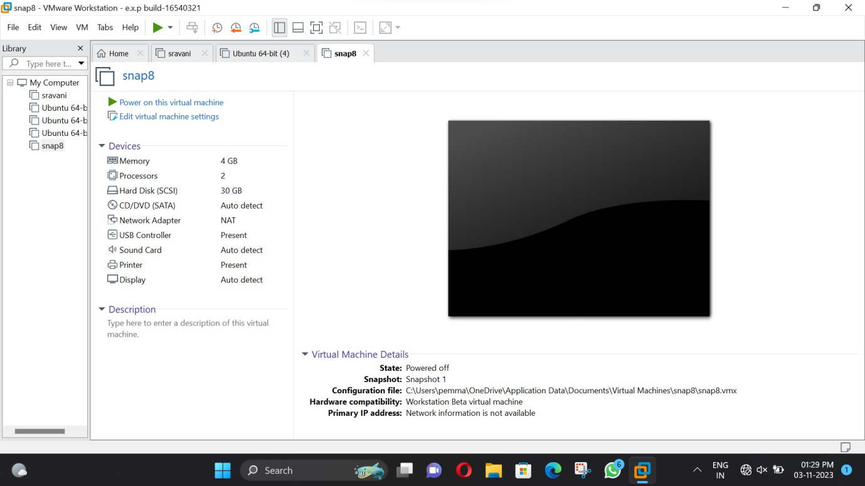

**Step 4:**

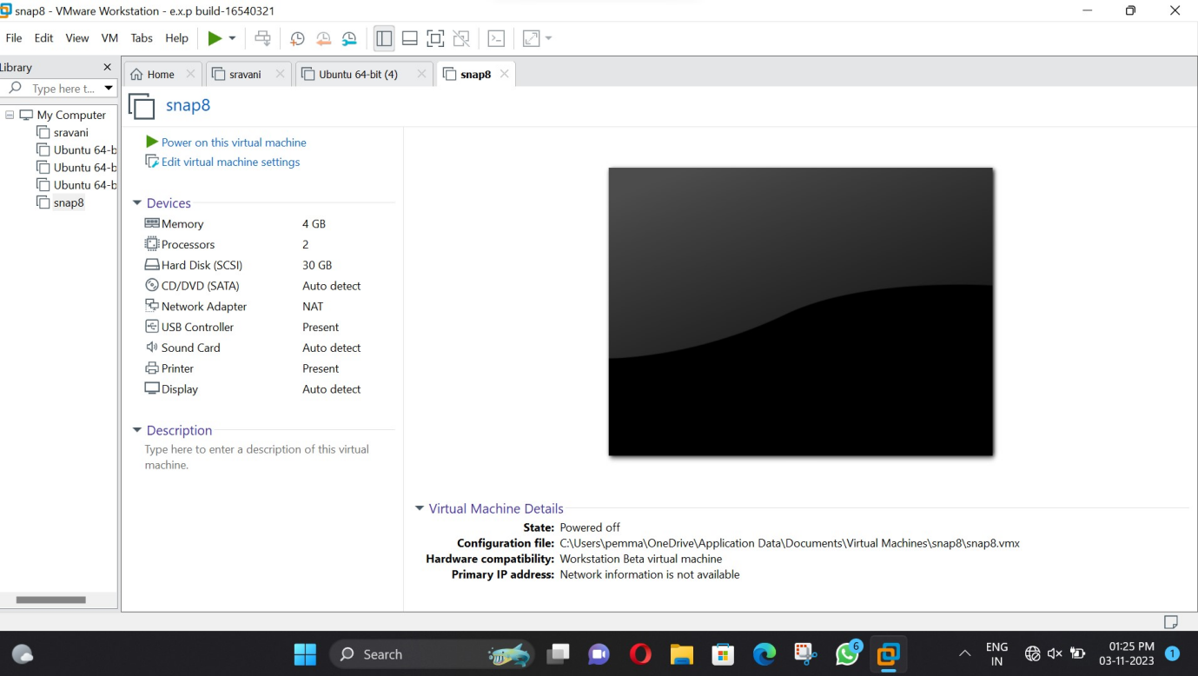

**Step 5:**

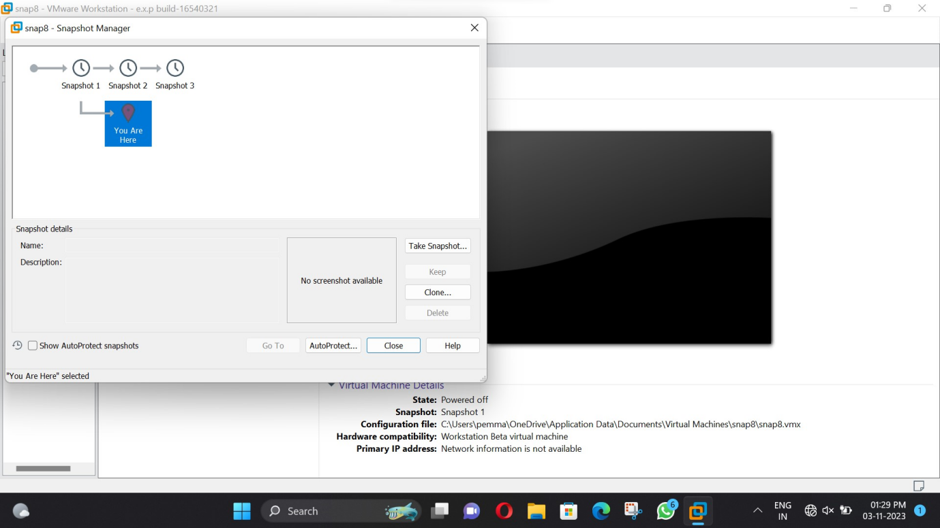

**Step 6:**

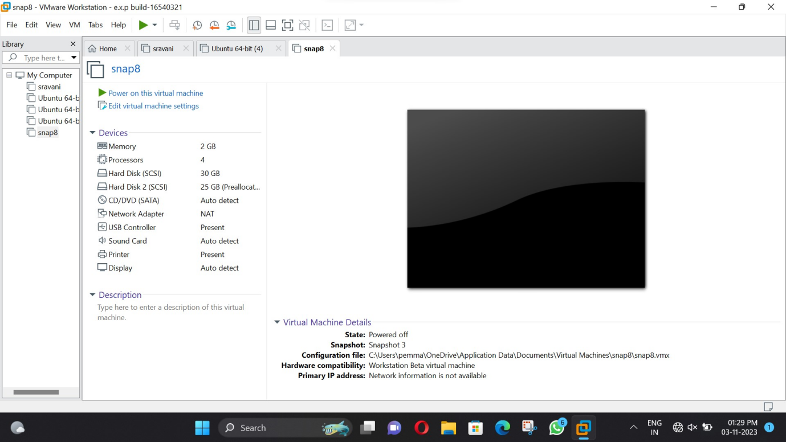

**Step 7:**

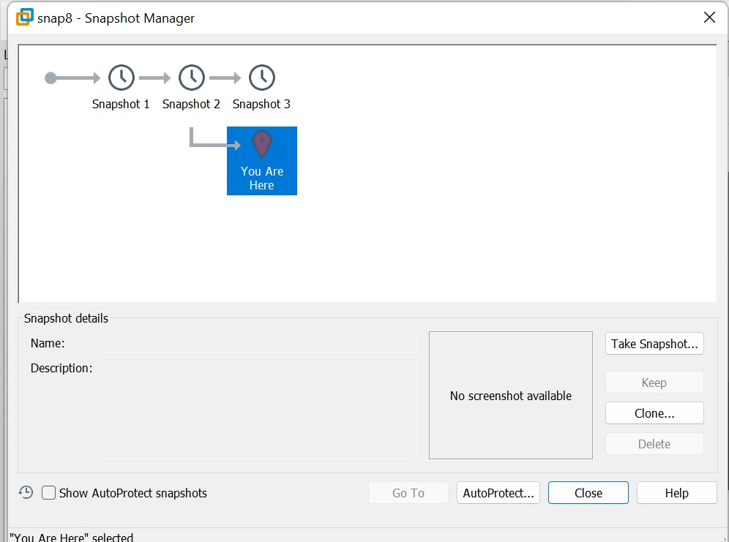

**Result:**

Successfully configure VM image with a VM and Test it by loading the Previous Version/Cloned VM using virtual box.